Java Programming

Lab Guide

Written By: Rony Keren
Internet Team
John Bryce training center

Exercise for modules 1 –5

Module 1 – Getting started

Exercise 1

- Examine the JDK installation on your PC
- Verify that the JRE is also installed
- Check environment variables setting
- Open the command prompt and try to run java.exe & javac.exe
- Create a file named Hello.java
- Copy the following code and save the file:
public class Hello {

public static void main (String [ ] args) {

System.out.println (“ Hello Java World ! “ );

}
}

- Compile the code via javac.exe in the command prompt
- Verify that the Hello.class file was generated
- Execute the program via java.exe

Module 2 – Packaging

Exercise 2

- Add to the Hello.java file a package declaration (at the top, before the class declaration):
package app.core;
- Compile the source into a package (using javac –d )
- Run the program via specifying the fully qualified class name (app.core.Hello)

Module 3-4 – Expressions & Flow control

All of the following exercises in this part should be implemented within main() method. No further classes or methods are required

Exercise 3 – output
- Create a class named Printer
- Define the following variables & initialize each with the specified values:
  - part1 – “There will be”
  - visitors – 5
  - part2 – “people for dinner.”
- Print the complete message
- run the program an test the result
- try to increment the number of visitors to 7 [visitors+2] in the print line
  - What happens when adding just visitors+2 ?
  - What is the right way of updating the print line ?

Exercise 4 – operators

- Create a class that defines 2 random numbers and prints
  - each number
  - the sum of the numbers
  - the average value
  - the remainder when dividing each in 10
  - the area of a rectangle where one num is the width and the other is the height
  - In order to randomize values between 0-100 use the following: int example = (int)(Math.random()*101);
  - Add a clear message to each printed value

Exercise 5 – conditions

- Create a class that defines 2 random numbers and prints
  - the bigger value

- Create a new class that defines a random number with a value between 0-100.
  - if the number is greater than 50 – print “Big !”
  - if the number is less then 50 – print “Small !”
  - if the number equals to 50 – print “Bingo !”

- Create a new class that defines a random number with a value between 0-100.
  - if the value is between 0-50 – print “Small !”
  - else – print “Big !”
in addition :
  - if the value is even (can be divided by 2) – print “Even”
  - else – print “Odd”

- Create a new class named “SalaryRaiser”
  - define a random number named ‘salary’ with a value between 5000-6000.
  - Now, raise the salary in 10% - only if the result is not greater than 6000 (which is the maximum salary allowed)
  - print the current salary and the updated salary

- Create a class that defines 3 random numbers and prints
  - the bigger value

- Salary taxes are calculated according to the following:
  - 0- 23,000 nis -> tax rate is 10%
  - 23,000- 50,000 nis -> tax rate is 20%
  - 50,000- 100,000 nis -> tax rate is 30%
  - 100,000 - up nis -> tax rate is 40%

Create a class named “TaxCalculator” that takes a salary of an employee (randomize a value to be used as an input) and prints the valid value after tax calculation

- Create a class that randomize a value to present a year (like 970, 1990, 2010 …) and prints the year and if it is leap year or not.
  - leap year must:
    - divide by 4
    - not divide by 100
    - if divided by 100 must also divide by 400

Exercise 6 – loops

- Create a class that defines a random number and prints all numbers from 1 to that number

- Create a class that defines two random values and prints all values between them. note - which variable holds the higher value is not known.

- Create a class that defines a random number and prints all even numbers from 0 to that number

- Create a class that defines two random values ‘max’ and ‘den’ and prints all the numbers from 0 to ‘max’ that can be divided with ‘den’

- Create a class that defines a random number with value between 0-10000 and print the following details with clear messages:
  - number of digits [4867 → 4]
  - the first left digit [ 6843 → 6]
  - sum of the number’s digits [ 473 → 14]
  - opposite order of the number’s digits [5892 → 2985]

- Create a class that defines a random value between 0-100,000 and prints if it is a palindrome (a symmetric number like: 12321, 666, 47974, 404 …)

- Create a class that defines a random number between 0-100 and prints the factorial value [4 → 1 X 2 X 3 X 4]

- Fibonacci set is an array of numbers. Each number is the sum value of the two previous numbers. The first number is 1 [1,1,2,3,5,8,13,21,34,55,89…]
Create a class that defines a random number named “index” with a value between 0-50 and prints the number in Fibonacci set that is located in the “index” position

- Create a class that defines a random value between 0-50 and prints Fibonacci set from 1 to that value

- Create a class named ‘Boom’ that implements the game “7-Boom” for all values from 0 to 100. The game rules are:
  - if the current number can be divided by 7 –print “boom”
  - if the current number has the digit ‘7’ – print “boom”
  - otherwise – print the number as is

Module 5 – Java Arrays

Exercise 7

- Create a class that creates an array[10] of numbers with random values between 0-100 and prints the total sum and the average

- Create a class that creates an array[50] of numbers with random values between 0-100 and prints the highest value and its index in the array

- Create a class that eliminates duplications. The class should be capable of getting an array with duplicated values and return an array of unique values generated from it. For example, for the input {1,2,5,1,6,1,5,4,8} the result should be {1,2,5,6,4,8}
  - create an array[10] of numbers with random values between 0-10
  - create an array with the required size to host the unique values
  - fill the unique array
  - print both arrays
- Create a class that reverse a given array order. For example, for the input {6,8,4,2,7,5} the result should be {5,7,2,4,8,6}.
  - create an array[10] of numbers with random values between 0-10 to be used as an input
  - print the array before and after reversing

- Create a class that calculates student average year grade.
  - create a matrix according to the following:
    - there are 20 students in class
    - there are 10 different grades per student (randomize values between 0-100 as input)
  - print each student average grade
  - print the class average grade

Exercise for modules 6 – 15

Bank System

System Description

Requirements:

The bank system holds a client list and allows them to deposit and withdraw cash money and also manage accounts

Bank system provides the following:
- client management – which includes
  - add/remove/update client
- account management
  - each client may own several accounts
  - clients can add/remove accounts
  - daily interest calculations – done automatically by the bank system
- Bank cash management
  - bank fortune is the total amount taken from client balances and accounts
  - operations that effect bank cash are:
    - commission for each withdraw or deposit made by the clients
    - closing / opening accounts
    - interest calculations on each account
- Activity log
  - Logs are records that describes the events that occurs along time
  - each Log object describes a single event
  - all the following events, that might effects bank cash balance, are logged:
    - add / remove client
    - update client balance
    - add / remove account
    - client deposit & withdraw
    - daily account balance update of accounts balance according to each interest
  - the system allows to view a logged information

Here is a description of the general structure and functionality of the Bank system:

Bank
- data members:
  - client list
  - log service
  - accounts commission updater
- functionality:
  - view balance - this operation must calculate the total bank balance each time the operation is called. The balance is calculated by summing the total client balance and the total accounts balance
  - add / remove client - (effects bank total balance & should be logged)
  - get client list
  - view logs – allows to view activities
  - start account updater daily process

Client
- details:
  - id
  - rank (regular, gold, platinum)
  - name
  - balance (instant money that can be withdrawn or deposited)
  - list of accounts
  - commission rate
  - interest rate
- functionality:
  - get methods for: id, name, balance, accounts
  - set methods for: name, balance
  - get fortune – returns the sum of client balance + total accounts balance
  - add account
  - remove account – money is transferred to the clients balance – no change in the bank total balance
  - deposit & withdraw – adds & removes money to clients balance – each action adds a commission to the bank total according to the following:
    - regular clients pays a commission rate of 3%
    - gold clients pays a commission rate of 2%
    - platinum clients pays a commission rate of 1%

  - update accounts balance (daily auto process)
    - regular clients gets a daily interest rate of 0.1%
    - gold clients gets a daily interest rate of 0.3%
    - platinum clients gets a daily interest rate of 0.5%

Account
- details:
  - id
  - balance
- functionality:
  - get methods for: id, balance
  - set methods for: balance

Log – each Log instance represents a single action (event) in the Bank system
- details:
  - time stamp
  - client-id
  - amount – the cash amount (+/-) of the operation
  - description – describes event details and will be one of the following:
    - "client added"
    - "client removed"
    - "client balance updated – deposit"
    - "client balance updated – withdraw"
    - "account update – closed"
    - "account update – opened"
    - "bank auto account interest update"
- functionality:
  - print details

Logger – is used to store and view Log messages
- details:
  - driver name (which will hold a DB driver for future use)
- functionality:
  - log – accepts a Log object and stores it in the Log DB
  - get logs – loads and returns all logs

Bank System

Phase 1 - System Design

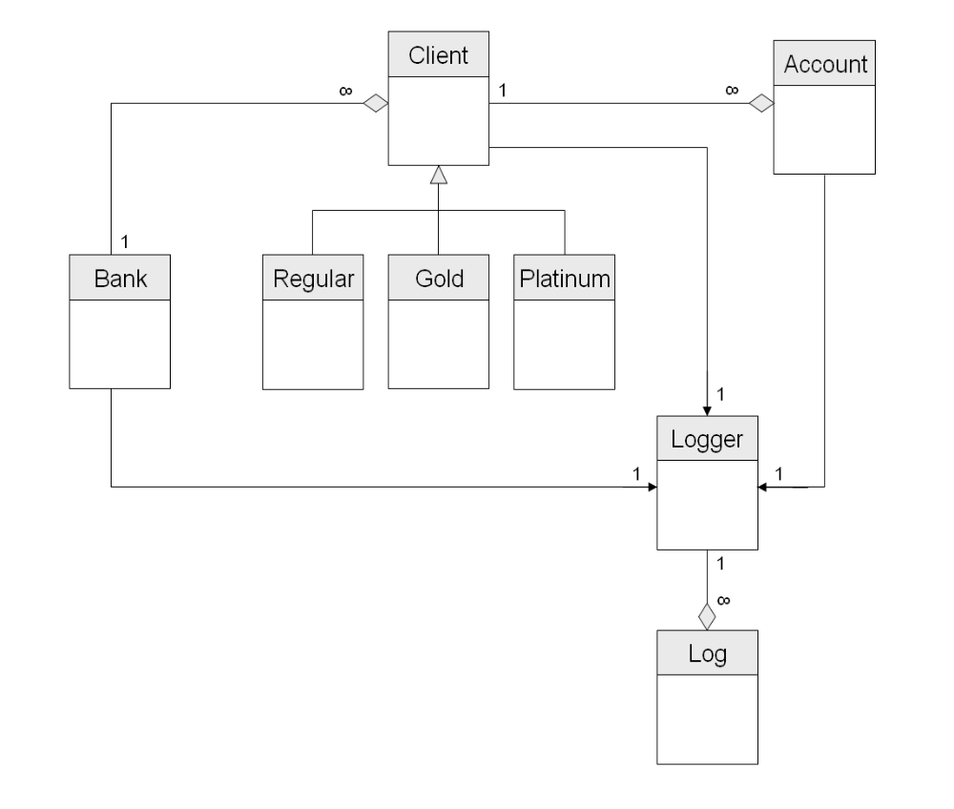

Module 6- encapsulation & basic flow control

Phase 2 – Building Classes

In this phase you'll create the building blocks of the bank system.
Later on, other bank features will be added to those classes.

In this phase the following classes will be defined:
Log
Logger
Account
Client
Bank

Classes details :

Log class
- Attributes:
  - timestamp – long – describes the time of action occurrence
  - client-id – int – the client-Id owning this action
  - description – String – short description of the action (messages are detailed in previous section)
  - amount – float – the amount of money of this action
- Methods:
  - Constructor (timestamp, client-id, description, amount)
  - getData() : String – append all action information into a string.
For example:
"2387781632, client-123, account update – opened, 120,000"

Logger class
- Attributes:
  - driverName – String – will be empty string by now
- Methods:
  - Constructor (driverName)
  - log( Log) : void - implement to print Log.getData() on screen.
NOTE: every time you see in this document "Log this operation" it means – create a new Log instance and use Logger.log(Log) to print its details.
  - getLogs() : Log[] - leave empty for now

Account class
- Attributes:
  - id - int
  - balance - float
- Methods:
  - Constructor (id, balance)
  - get methods for: id, balance
  - set methods for: balance - log this operation

Client class
- Attributes:
  - id - int
  - name - String
  - balance - float
  - accounts – Account [5]
  - commission rate – float (value=0 for now)
  - interest rate – float (value=0 for now)
  - logger - Logger
- Methods:
  - Constructor (id, name, balance) – constructs a new client with zero accounts. Constructor also instantiates the Logger.
  - get methods for: id, name, balance, accounts
  - set methods for: name, balance
  - addAccount (Account) : void - add the account to the array and log the operation.
You should seek the array and place the Account where the first null value is found.
Clients shouldn't be able to add Accounts with already existing IDs.
- getAccount(int id) : Account – returns the account with the specified id or null if does not exist
  - remove account (int id) : void - remove the account with the same id from the array (by assigning a 'null' value to the array[position]) & transfers the money to the clients balance. Log the operation via creating Log object with appropriate data and sending it to the Logger.log(..) method.
  - deposit(float) & withdraw(float) : void - implement to add / remove the amount from clients balance according to the commission (which is now zero). Use the commission data member in your calculation). Example: if a client deposits 1000, the actual amount added to his account will be = 1000-commission. If a client withdraws 1000, the actual amount taken from his account will be = 1000+commission.
  - autoUpdateAccounts() : void – this method loops over the client accounts, calculates the amount to add according to the client interest (meanwhile it is zero) and adds it to each account balance. Use the interest data member in your calculation. Log this operation.
Note: this method will be invoked once a day by a background thread – we will add it in future phases.
  - getFortune() : float – returns the sum of client balance + total accounts balance.

Bank class
- Attributes:
  - clients – Client [100]
  - logService - Logger
  - account updater – leave this one for now, we'll add it later
- Methods:
  - An empty constructor that instantiates the clients array
  - getBalance() : float - this operation returns the bank balance. The balance is calculated by summing the total clients balance and the total accounts balance – you should use Client.getFortune() method of each client. The function sums all clients balances and return the total as the bank current balance.
  - addClient(Client) : void - adds the client to the client array and log the operation.
You should seek the array and place the Client where the first null value is found.
  - removeClient(int id) : void - remove the client with the same id from the array (by assigning a 'null' value to the array[position]). Log the operation
  - getClients() : Client []
  - view logs – prints all logs that are stored in the logger – leave empty for now
  - startAccountUpdater() : void - leave empty for now

Note :
  - Currently the timestamp value sent to the Log constructor should be zero.
  - Currently, "log this operation" means creating a Log object, filling it with the action details and print it via Logger.log(Log) which invokes and prints the Log.getData();

Module 6-7 Inheritance & polymorphism

Phase 3 – System Core

In this phase you'll create the different types of Clients and implement more functionality in the bank system.

In this phase the following classes will be defined all extends Client.class:
- RegularClient
- GoldClient
- PlatinumClient

Bank class:
- Turn this class into a Singleton
- Add a private float static field totalCommission to sum all commissions due to client withdraw & deposit operations.
- Add public static method updateTotalCommission(float) that allows to update the totalCommission field. Clients will use this static method in order to add withdraw/deposit commissions. We will update Client.class to do it in the next step.
- Update setBalance() to add the commissionSum to the bank total balance
- Add a new method – printClientList() : void that prints the client details using the new toString() implementation you'll create in the next step.
- Update removeClient(id) to take a Client: Bank.removeClient(Client) and perform the check using Client.equals(Object) method

Client class:
- Add the following attributes
  - commissionRate – final, float, protected
  - interestRate – final, float, protected
- Update Client to be an abstract class
- Change both interest & commission access modifiers to be
protected instead of private
- Update withdraw() method to calculate commission according to
the amount & commission rate and call Bank.updateTotalCommission(float) in
Bank class to add the commission to the bank totalCommission.
- Override the equals() method to perform the check according to
client id value.

Sub-Classes details :

RegularClient, GoldClient, PlatinumClient
- all extends Client
- all have default constructor which populates commissionRate & interestRate according to the following:
  - commission rate – float with a fixed values:
    - regular clients pays a commission rate of 3%
    - gold clients pays a commission rate of 2%
    - platinum clients pays a commission rate of 1%
    - relevant for withdraw operation only
  - interest rate – float with a fixed values:
    - regular clients gets a daily interest rate of 0.1%
    - gold clients gets a daily interest rate of 0.3%
    - platinum clients gets a daily interest rate of 0.5%
    - later, a system thread will use it
  - Note: all calculations should work fine since now the relevant interest & commission values are used.
- Override toString() method to return the client type (as a String – "Platinum", "Gold", "Regular") and ID

Account class:
- Override the equals() method to perform the check according to
the id value.
- Update the Client.removeAccount(id) to take an Account
[Client.removeAccount(Account)] and perform the check
using Account.equals(Object) method

Logger class:
- Update log(Log) method to be static
- Update all log creators to use Logger.log(...) method. Replace your code with Logger.log(...) wherever you instantiate a Logger object. Logger instances should never be created.

Log class
- Override toString() method to print log details (client ID, message & timestamp) – you may simply change the 'getData()' method name

Module 8 - Exceptions

Phase 4 – Exceptions

In this phase you'll create a system exception indicates on problems when performing a withdraw operation

In this phase the following class will be defined:
WithdrawException

WithdrawException.class details :

- extends Exception
- Attribures:
  - clientId : int
  - currentBalance : float
  - withdrawAmount : float
- Functionality:
  - Constructor (message, clientId, currBalance, withdrawAmount)
  - get methods for clientId, currBalance, withdrawAmount

Client class:
- Update withdraw(float amount) method to throw WithdrawException if the amount to withdraw is greater than the current client balance.

Module 9 - Java utilities & Collections

Phase 5 – Adding Java Utilities

In this phase you'll update your system to work with Java Collections instead of static arrays.

Bank class:
- change clients attribute from array into ArrayList
- update the addClient(..) and removeClient(..) methods accordingly

Client class:
- change accounts attribute from array into ArrayList
- update the addAccount(..) and removeAccount(..) methods accordingly

Logger class:
- change the empty getLogs() method to return an ArrayList

Log class:
- Update Log toString() method to convert the timestamp from long into a java.util.Date

- Update all log generators to use a real timestamp by creating new Date() objects and assign it to Log constructor

Module 10 - Java Tiger syntax

Phase 6 – Updating code

In this phase you'll update your application to be type-safe and use auto-boxing

- Update all classes that use Java collection to use type-safe collections via generics
  - Bank – ArrayList<Client>
  - Client – ArrayList<Account>
- Update, where necessary, wrapper classes to use auto-boxing

Module 11 - Java I/O

Phase 7 – Storing Data in Files

In this phase you'll update your system to store all clients data in files.

Client & Account classes:
- Update the two classes to be Serializable

Bank class:
- create a store() method to store the clients ArrayList in a file named "bank.data" binary file
- create a load() method that loads the data and call this method from the Bank constructor.
- Update the constructor to load the clients from a file on creation. If the constructor fails to load the file it creates an empty client ArrayList (this happens when you first launch the Bank application and no clients exists or in cases where bank.data is corrupted or missing).

Note: when reading an object from a file the return type of the ‘readObject()’ method is java.lang.Object. This is a non-type-safe operation but there is nothing you can do but down-casting and suppress warning.
In order to transform a loaded collection into a type-safe one – use this: clients = Collections.checkedList(theListFromFile)
This methods verifies that all the elements in the collection are of the expected type (in our case - Client.class) and results with a type-safe collection that matches the Bank.clients attribute

Module 12 - Multitasking – Java Threads

Phase 8 - Combining Threads

In this phase you'll update your system to perform an asynchronous operation for daily client accounts update.
The daily update is done on each account – adding an amount of money according to the clients interest.
For example – if a client has 1000 in his balance and the commission value is 0.1 – than the client earns 10 each day.

- Create a new class named AutoUpdater that:
  - implements Runnable
  - Constructor that takes Clients ArrayList
  - Override run() method to scan each client account and call the Client.autoUpdateAccounts() method (which updates all client accounts balance with the interest). After updating all clients the method will sleep for the next 24 hours.
  - Verify that Client.autoUpdateAccounts() calculates the interest rate and adds it to each account (each client type has its own interest rate) – it should, since we have implemented it in previous phases.

- Bank class
  - Implement the startAccountUpdater() method to create a thread with AutoUpdater task and starts it.
  - Update the constructor to call the startAccountUpdater() on startup.

Module 13 - Data-Base connectivity - JDBC

Phase 9 – Storing Data in DB

In this phase you'll update your system to store log messages to the DB

- Create a database table named LOG_TABLE with the following fields:
  - timestamp – DATE
  - clientID – NUMBER (INT)
  - description – VARCHAR2 (STRING)
  - amount – (DOUBLE / FLOAT)

- Log class:
  - Change timestamp from java.util.Date into java.sql.Date.
  - Now you will have to fix bugs in your code since java.sql.Date doesn't have an empty constructor. In order to create a Date with current time simply use this:
Date d = new Date (System.currentTimeMillis());

- Logger class:
- add a static Connection as a data member of this class
- update the constructor to generate a connection using the given driver name
- update the empty log() method to store the Log object in the DB
- update the getLogs() method to:
  - be static
  - perform a "SELECT * FROM LOG_TABLE"
  - return a Log objects ArrayList

- Bank class:
  - viewLogs() – update the method to use the getLogs() from Logger in order to obtain all log messages and print them to the screen.

